**NAME - PRANAV SANDEEP RAIKAR ROLL NO - 43**

**DIV - D10A BATCH - B**

**Commands for File System Management and User Management**

**LAB 3**

**Study of Unix file system (tree structure), file and directory permissions, single and multiuser environment.**

The Unix file system is organized in a hierarchical tree structure, with the root directory (denoted by '/') as the top-level directory, and other directories and files branching off from it. Directories can contain other directories and files, allowing for a hierarchical organization of data.

In Unix, file and directory permissions determine who can access, read, write, and execute files and directories. File permissions are specified using a set of nine bits that correspond to the permissions for the owner of the file, the group associated with the file, and all other users. Each set of three bits represents the read, write, and execute permissions for the corresponding user or group. For example, the permission string "rwxr-xr-x" indicates that the owner of the file has read, write, and execute permissions, the group has read and execute permissions, and all other users have read and execute permissions.

In a single-user environment, only one user has access to the computer and its file system. In this scenario, file and directory permissions are not as important, since there is only one user who needs access to the files.

In a multi-user environment, multiple users have access to the computer and its file system. In this scenario, file and directory permissions play a crucial role in determining who can access and modify files. This helps to ensure the security and privacy of sensitive files, and prevents unauthorized access and modification of files by other users.

**Execution of File System Management Commands**



The **pwd** command writes to standard output the full path name of your current directory (from the root directory).

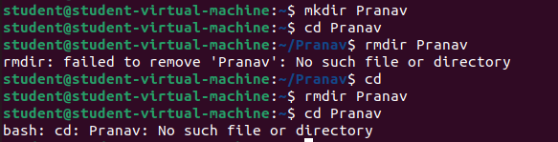

The mkdir command in Linux/Unix allows users to create or make new directories.

cd command changes from one directory to another.

rmdir removes directory

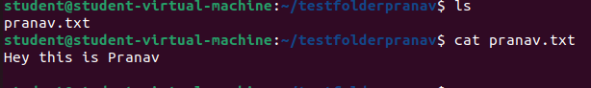

**cat** is a standard Unix utility that reads files sequentially,

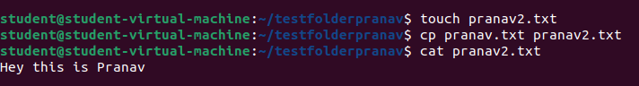

touch command creates a new file

cp command copies the content from first file mentioned to second file mentioned

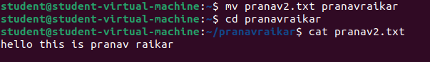

mv command is used to move one file to another file



chmod sets permissions to access the files

0 in the above command denies all permissions on the file



The wc command in UNIX is **a command line utility for printing newline, word and byte counts for files**. It can return the number of lines in a file, the number of characters in a file and the number of words in a file.





We can find the number of lines that matches the given string/pattern

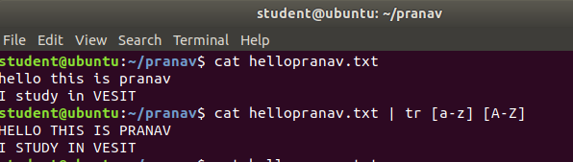

The tr command is a UNIX command-line utility for translating or deleting characters. It supports a range of transformations including uppercase to lowercase, squeezing repeating characters, deleting specific characters, and basic find and replace. It can be used with UNIX pipes to support more complex translation. tr stands for translate

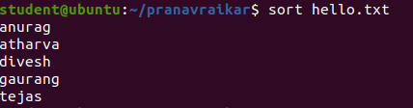

**SORT** command is used to sort a file, arranging the records in a particular order. By default, the sort command sorts file assuming the contents.

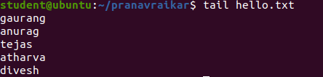

The **tail command**, as the name implies, print the last N number of data of the given input.

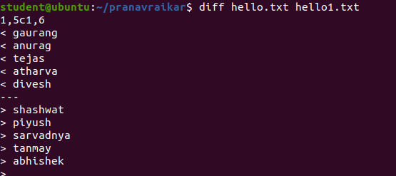

diff stands for **difference**. This command is used to display the differences in the files by comparing the files line by line. Unlike its fellow members, [cmp](https://www.geeksforgeeks.org/cmp-command-linux-examples/) and [comm](https://www.geeksforgeeks.org/comm-command-linux-examples/), it tells us which lines in one file have is to be changed to make the two files identical.

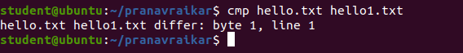

**cmp** command in Linux/UNIX is used to compare the two files byte by byte and helps you to find out whether the two files are identical or not.



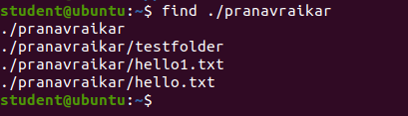

The **find** command in UNIX is a command line utility for walking a file hierarchy. It can be used to find files and directories and perform subsequent operations on them. It supports searching by file, folder, name, creation date, modification date, owner and permissions.



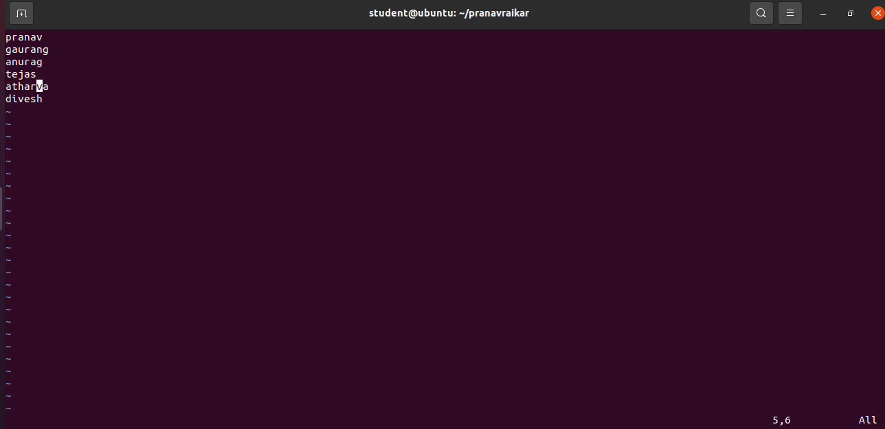

**Vim** is an advanced and highly configurable text editor built to enable efficient text editing. Vim text editor is developed by Bram Moolenaar. It supports most file types and vim editor is also known as a programmer’s editor. We can use its plugin based on our needs.

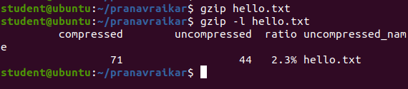

In general, **GZIP** is much better compared to ZIP, in terms of compression, especially when compressing a huge number of files.

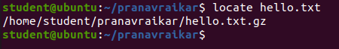

***locate***command in Linux is used to find the files by name. There are two most widely used file searching utilities accessible to users are called find and *locate*. The *locate* utility works better and faster than *find* command counterpart because instead of searching the file system when a file search is initiated, it would look through a database.

**Execution of User Management Commands :-**

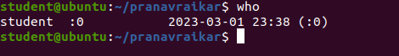

who command is a tool to print information about users who are currently logged in. who commands only to see a real user who logged in. On most Linux distribution, who command is already installed.

The whoami command **allows Linux users to see the currently logged-in user**. The output displays the username of the effective user in the current shell. Additionally, whoami is useful in bash scripting to show who is running the script.

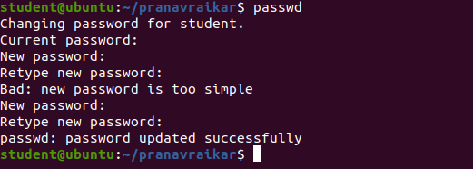

The passwd command **changes passwords for user accounts**. A normal user may only change the password for their own account, while the superuser may change the password for any account.

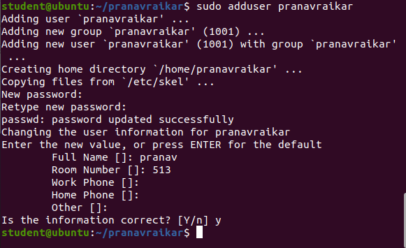

**useradd** is a Linux command for **creating a new user**. It requires various options to add and set up an active user account. Additionally, the command allows changing default values for the user creation process. useradd is a low-level, portable command available on all Linux distributions.



**usermod** command or modify user is a command in Linux that is used to change the properties of a user in Linux through the command line. After creating a user we have to sometimes change their attributes like password or login directory etc.

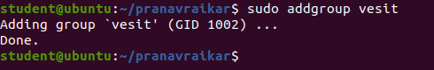

**addgroup** command in Linux is used to add a new group to your current Linux machine. This command allows you to modify the configurations of the group which is to be created.



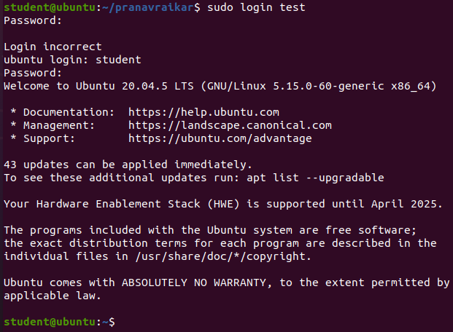

The **login** program is used to **establish a new session with the system**. It is normally invoked automatically by responding to the "login:" prompt on the user's terminal. login may be special to the shell and may not be invoked as a sub-process.

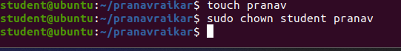

**chown**

Different users in the operating system have ownership and permission to ensure that the files are secure and put restrictions on who can modify the contents of the files. In Linux there are different users who use the system:

* Each *user* has some properties associated with them, such as a user ID and a home directory. We can add users into a group to make the process of managing users easier.
* A *group* can have zero or more users. A specified user can be associated with a “default group”. It can also be a member of other groups on the system as well.

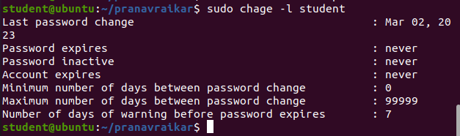

The **chage** command **changes the number of days between password changes and the date of the last password change**. This information is used by the system to determine when a user must change their password.

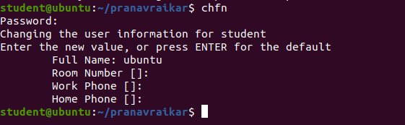

In Unix, the **chfn** (change finger) command **updates the finger information field in your /etc/passwd entry**. The contents of this field can vary among systems, but this field usually includes your name, your office and home addresses, and the phone numbers for both.